


•
•

2026 Most Beautiful Yard Program Nomination Form - Due Date May 1, 2026
Neighborhood Association: _ Contact Person: _
Phone Number:
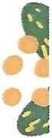
.. EmaiI:

Nominate three homes to be considered by the selection committee. Please note the selection committee may not review the neighborhood submission if they do not receive three nominations. Include as much information about the owner to help us contact the winner.

Address of Home #1: Name of homeowner: ______
Phone Number:


Address of Home #2: Name of homeowner: _____ Phone Number:
--
....

Address of Home #3: Name of homeowner: ____ Phone Number:

Please return this form and at least 3 photographs of each home from the front-angle, side angle, -and close up of the front yard to: comlinksantaana@gmail.com
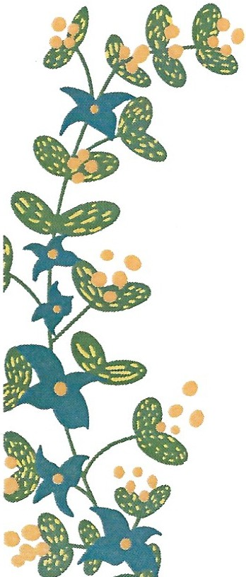

Due Date is May 1, 2026
Please send at least three (3) electronic photos in jpeg format, of each home your neighborhood is nominating, along with this nomination form to: comlinksantaana@gmail.com

Please include the neighborhood name in the subject line, and please name the jpeg files with the address of the home(s).
For questions, please contact comlinksantaana@gmail.com

Thank you

