
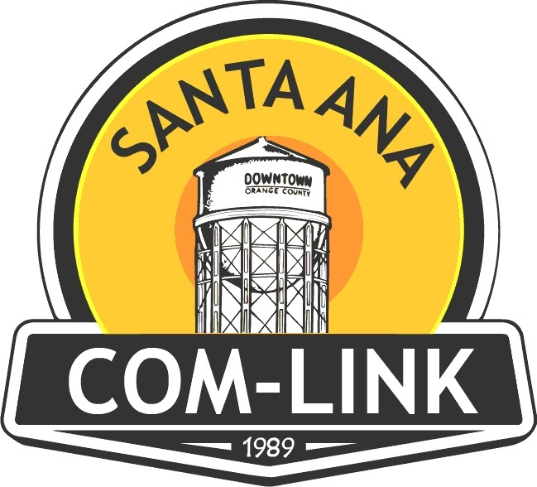

Neighborhood Hero Nomination Form
DEADLINE: May 1, 2026, AT 5 P.M.

Neighborhood Association:
Nominee’s Name:
Nominee’s Address:
Nominee’s Telephone #:
Nominee’s Email Address:
Submitted By:
Submitter’s Email Address: Submitter’s Telephone #:
What makes someone a Neighborhood Hero?
A Neighborhood Hero is someone who continuously gives their time and labor in the service of others in their neighborhood.
A Neighborhood Hero is someone who continuously works to improve your neighborhood, block by block to make the neighborhood, and Santa Ana a better place.
Examples of activities that would make someone a Neighborhood Hero:
- A Neighborhood Hero could be a volunteer for a local charity,
- An organizer of youth or neighborhood activities on a regular basis,
- It could be someone who organized a neighborhood book club or volunteers to read to others,
- Or someone who supervises safe outdoor play hours for neighborhood children or,
- Someone who volunteers to spruce up a neighbor’s yard, a local park or school.

What has your nominee done to show they are a Neighborhood Hero? Please be specific in your description of what the nominee has done to show they are someone who continuously gives their time and labor in the service of others in your neighborhood.
Please email completed nomination form to: comlinksantaana@gmail.com
Deadline for nomination forms is Friday, May 1, 2026

